

SYT/BS Exercise Report

Name | Nils Piskorz
4 or 5 – Digit Login-Number | 4128
Class | 3Bl
Date of Exercise | xx.yy.2026
Date of Submission | xx.yy.2026
Exercise Number | 0w
Teacher | NOE
Topic of Exercise | UE02_Linux_File_Access_Control_II

Inhalt

Bitte den folgenden Text kopieren (Strg-A/Strg-C) und dann in Kopie des Deckblatts einfügen!

Objective
This lab exercise will provide additional insights into security of Linux file systems, in particular with regards to file access control features. We will build upon the security setup of our little example organization (Gotham City) from the previous lab exercise.

Refresh: Platform and process
- You will need a Linux-system where you have superuser (root) privileges (with sudo oder su) – please use the prepared Kali VM running (the privileged sudo-user is called junioradmin)!
- Execute all commands in a terminal window using the standard shell and don’t forget to elevate your privileges first using e.g. sudo su!
→ Be sure to provide answers to all questions and to document each and every shell command line in your lab notes (lab report)! In particular:
- Provide all important command options you are using and always list the resulting permissions (for permissions on directories use e.g. ls -ld dirname )
- Don’t forget that in order to use a directory “normally”, you need to grant r-x permissions at minimum (to list contents, to cd to the directory, to access files in the directory)!

Refresh: Creating users and groups
- If not already done, create the following users, groups and directories on the system (use the script addusers.sh you developed in lab “Linux User Management” or “Linux Benutzerverwaltung”!):
• Existing users, groups and home directories verified; admin account: admin28.
Note: If you already did this successfully in a previous lab, you can skip this step! Otherwise, use a simple shell script with one command per line!
Hint: See lab “Linux User Management” or “Linux Benutzerverwaltung”; xx are the last two digits of your login-number!

Username | Full Name | Login Group | Home Directory | Password
adminNN | YourName | heroesNN | /home/heroesNN/adminNN | linux!is!c00l!
batman | Bruce Wayne | heroesNN | /home/heroesNN/batman | darkknight
robin | Dick Grayson | friends | /home/friends/robin | nightwing
catwoman | Selina Kyle | friends | /home/friends/catwoman | meowmeow
gordon | James Gordon | police | /home/police/gordon | law-n-order
joker | The Joker | villains | /home/villains/joker | whysoserious
penguin | Oswald Cobblepot | villains | /home/villains/penguin | fish!
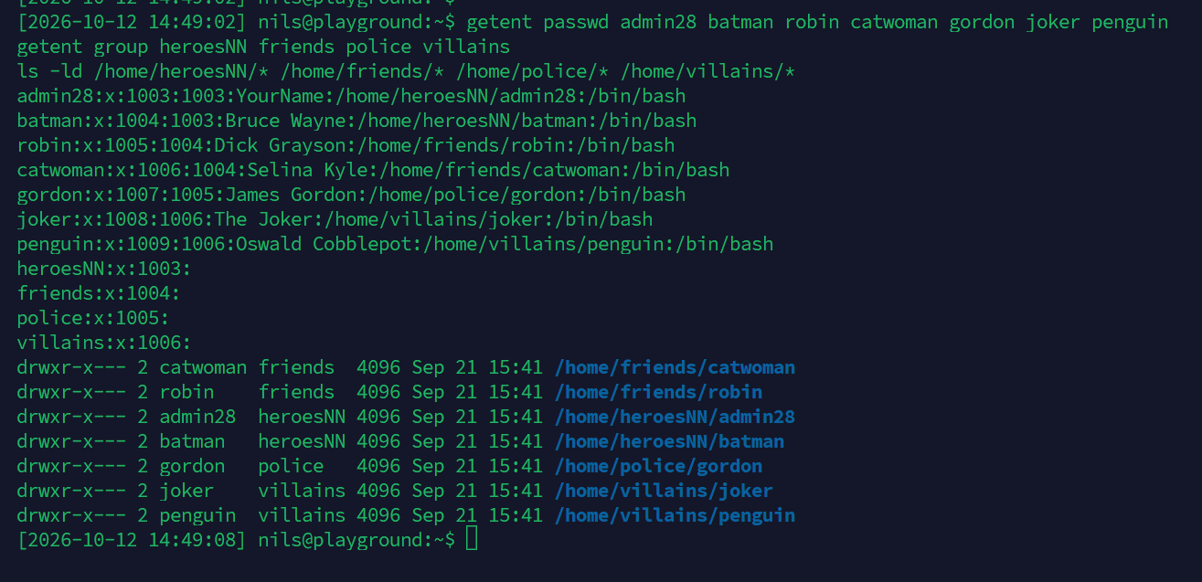

Refresh: Creating Data Directories
You should have already been done the following three tasks during your previous lab-session:
- Create /data26/* directories for the groups friends, police and villains to use with corresponding names /data26/friends, /data26/police and /data26/villains. Owner in all cases is root.
• Created /data26/friends, /data26/police and /data26/villains; owner: root.
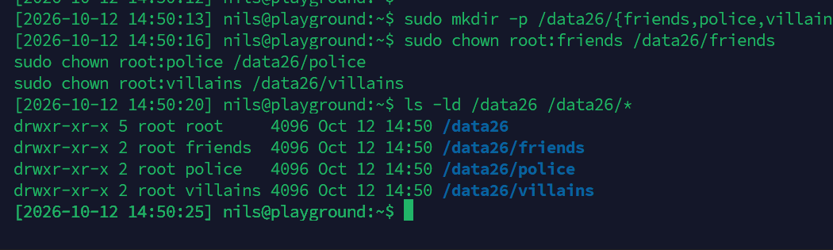
- Members of the respective group shall have full access to their directory (they are also permitted to write), all others have no access rights.
• chmod 770: owner and group rwx; others no access.
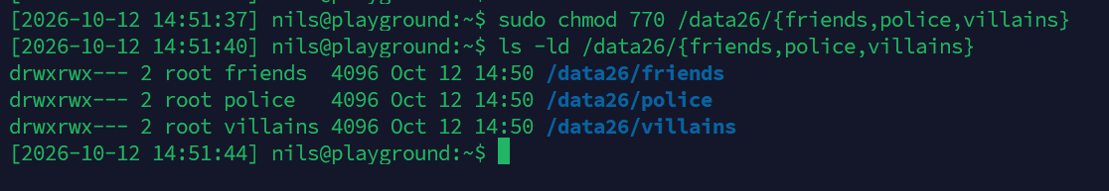
- batman should nevertheless be permitted full control (including write permission) over these directories.
• Batman added to friends, police and villains using usermod -aG.
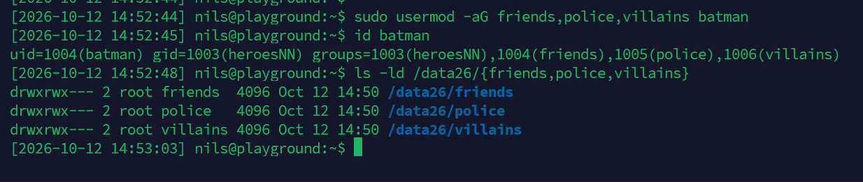
- Create a special directory /data26/gotham with batman having full access (including the permission to create, delete and rename files), but all other users having only read access to the directory (they may “use” the directory, but not write to it, i.e. they may not create new files, rename files or delete files).
• /data26/gotham: batman:heroesNN, permissions 755 (rwx/r-x/r-x).
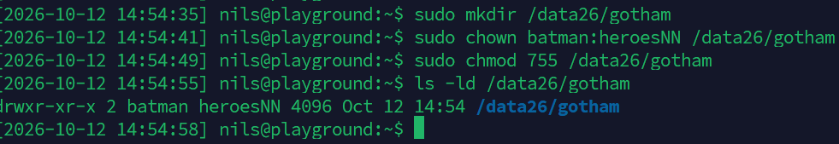

File Permissions – Fine Tuning
Solve all tasks by using the standard Unix/Linux access control system (you will not need ACLs e.g. the setacl command)!
- Check and, if required, correct the access permissions for the parent directory /data26: Owner should be root (full control), all others should only be permitted to read the directory contents and navigate into this folder.
• /data26 owned by root:root; permissions 755.
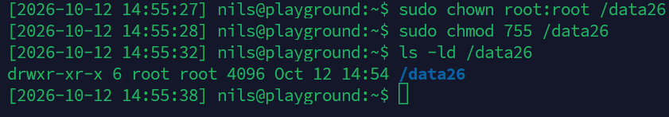
- Change the permissions on the three group directories /data26/* (those private to each group) in such a manner that any new file created automatically receives the group of the directory itself (and not the group of the file creator)!
• SETGID enabled (chmod g+s); new files inherit directory group.
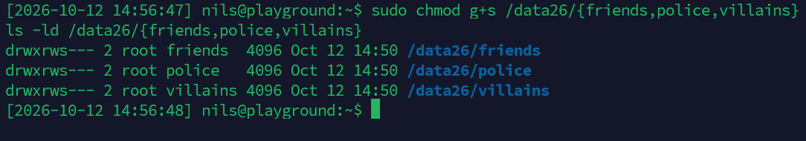
- Create a directory /data26/transfer. It will serve as a data exchange folder to easily share files between different groups of users and should permit the following access patterns:
  - Administrator of /data26/transfer shall be gordon: This user shall have full control of this folder and also be permitted to clean it up, i.e. delete files.
  - All users should be able to create files in this folder, but they should not be able to delete any files they do not own.
  - Any file that is created in this directory should automatically receive the (new) group transfer.
• transfer owned by gordon:transfer, mode 3777; SETGID + sticky bit.
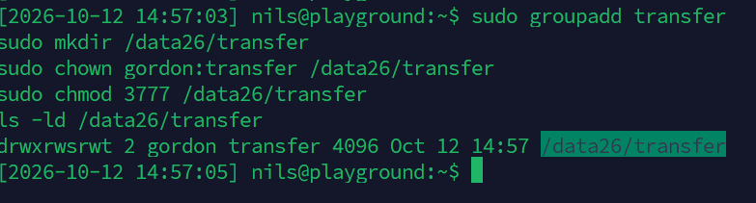
- Test this by creating the following file in each of the directories /data26/* when working as user root:
  - filename is xx.txt (xx are the last to digits of your login-number again)
  - xx.txt consists of the text “This file has been created by Your name!”
Maybe you need to “mask” the “!”?
• Created 28.txt in each folder as root; single quotes preserve the exclamation mark.
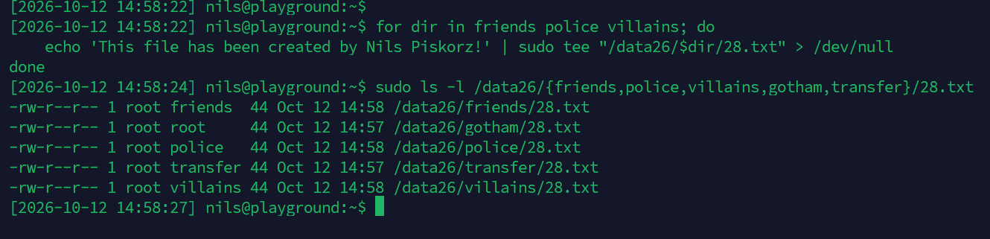
- How does ls -l display these refined permission settings (Hint: STICKY BIT, SETGID BIT)?
• SETGID appears as “s” in group execute; sticky bit as “t” in others execute.
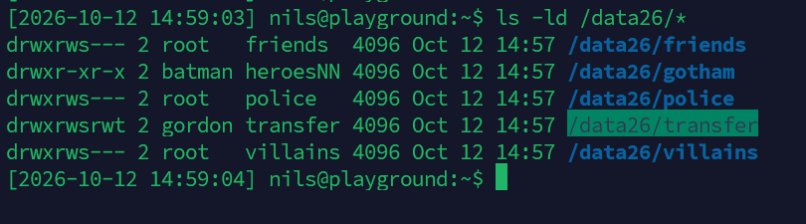
- Issue the command sudo find /data26 -ls and copy the output into your lab report.
• Full find output is shown in the screenshot below.
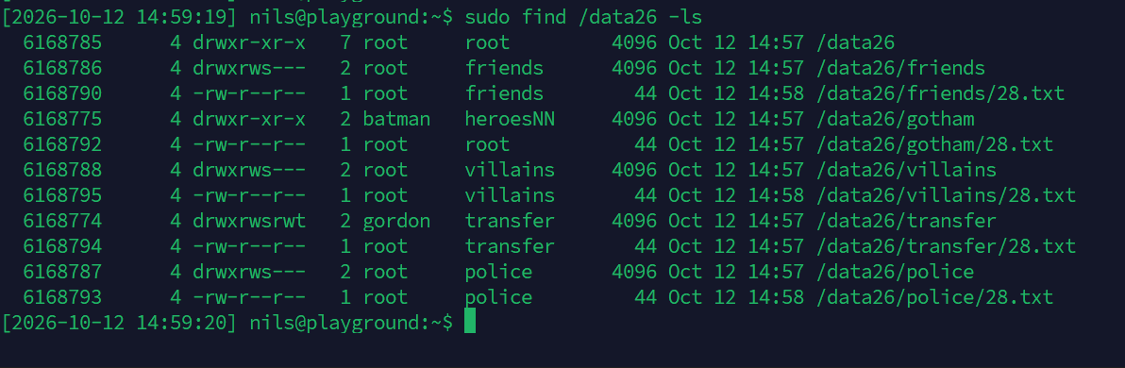

Testing our Security Setup
Verify the access control settings as described below. Check the following items for each:
- Note down precisely which commands you used!
- Take note in your lab report whether the prescribed action was successful (or not!) and why exactly!
Is this the expected outcome?
• Yes: successes and permission denials match the configured access rules.
- How did you change your user-id?
• Used sudo -u <username> to execute commands as another user.
- As user catwoman: Create three files in /data26/transfer: file1.txt to file3.txt, each one with the corresponding content “filex.txt by catwoman”. Create the text content of the files using the command line (not by using a text editor)! What group are these files associated with?
• Created file1–file3 as catwoman; all belong to group transfer (SETGID).
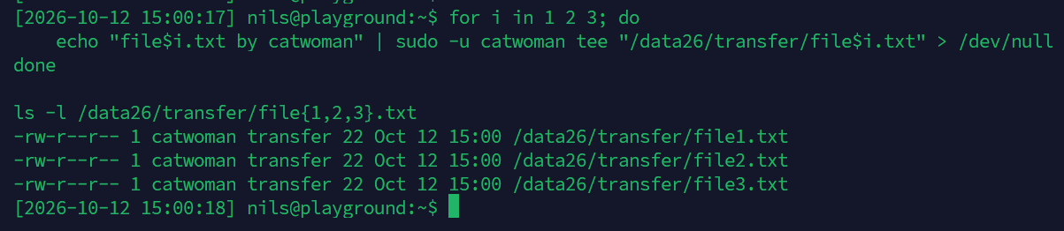
- As user gordon: Create two additional files file4.txt and file5.txt in /data26/transfer, each one with the content “filex.txt by gordon”.
• Created file4.txt and file5.txt as gordon; group transfer.
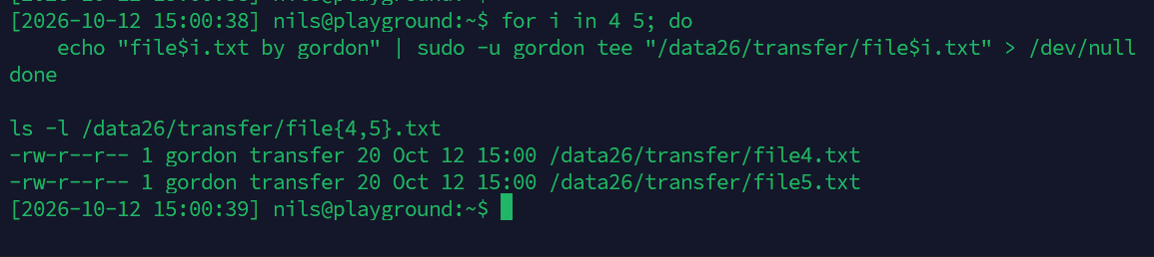
- As user robin: Copy file1.txt to /data26/friends and then delete the source file.
• Copy succeeded; deleting catwoman’s source failed (sticky bit).
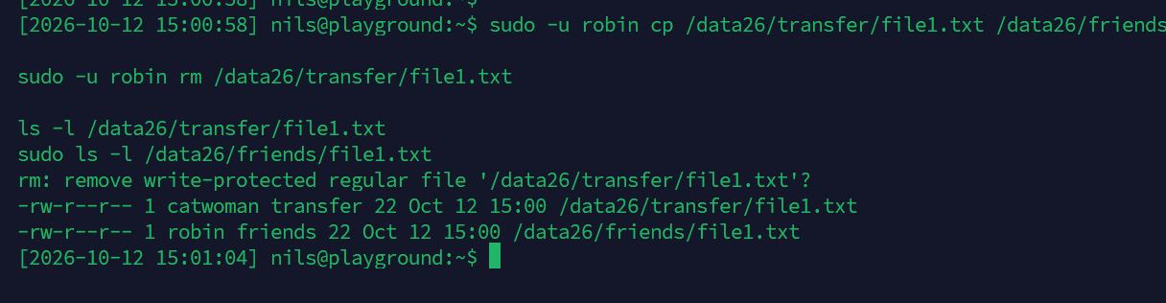
- As user joker: Create the file playingcard.txt in /data26/villains, then copy it to /data26/transfer.
• Creation and copy succeeded; groups villains (original) and transfer (copy).
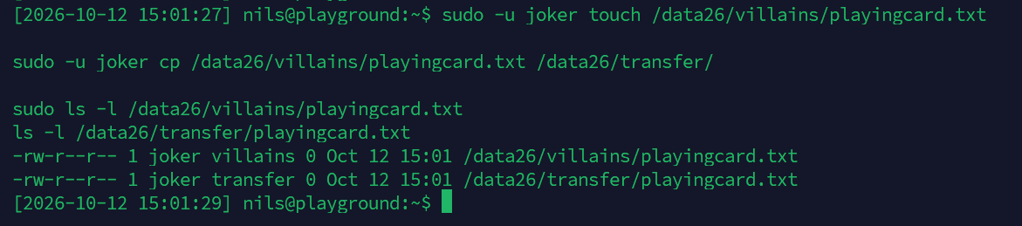
- As batman: Copy file2.txt to /data26/friends, /data26/police and /data26/villains. Further, delete the file playingcard.txt in /data26/transfer.
• Three copies succeeded; deleting joker’s playingcard.txt was denied (sticky bit).
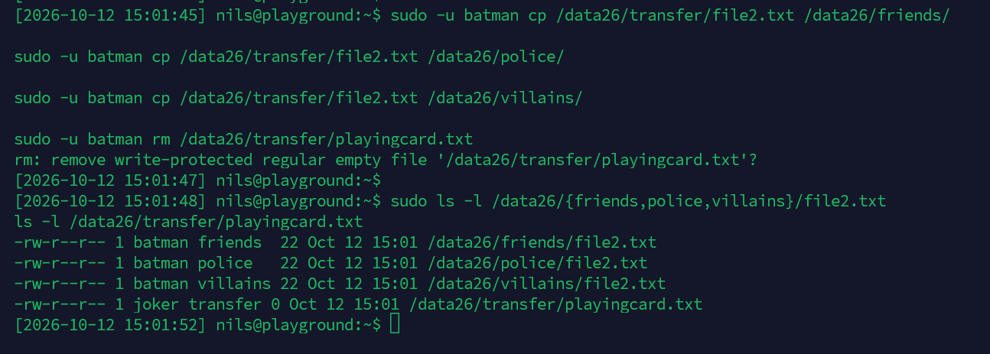
- As catwoman: Delete the files playingcard.txt and file1.txt in /data26/transfer
• Cannot delete joker’s playingcard.txt; can delete own file1.txt.
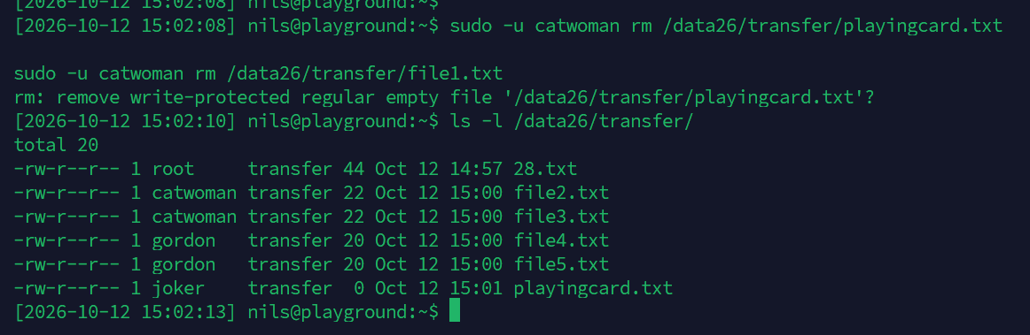
- As gordon: Delete the files file2.txt and playingcard.txt in /data26/transfer, then move file3.txt to /data26/police.
• Gordon can delete any file in transfer as directory owner; file3.txt moved to police. Screenshot shows interactive rm prompts, so deletion success is not confirmed there.
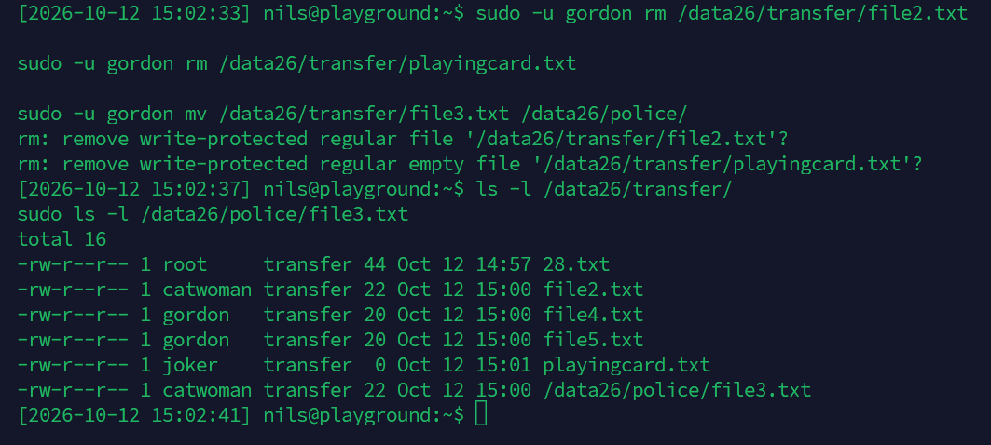
- As gordon:
  - Create a hard link just4me.txt in /data26/police that points to the same file as
/data26/transfer/file4.txt.
• Hard link created; both names reference the same inode.
  - Change the permissions of just4me.txt in such a manner that only gordon can read and write this file (nobody else has permissions for accessing this file).
• chmod 600: only owner gordon has read/write access.
  - Test if gordon can indeed read the file using cat.
• cat succeeded; content: “file4.txt by gordon”.
  - How did the access permissions of /data26/transfer/file4.txt change in the course of this operation?
• file4.txt also changed to 600; hard links share file permissions.
  - Use the stat command to check the inode-information of these files – What is their inode-number? What value does their link counter have?
• Same inode for both names; link count = 2 (see stat screenshot for inode number).
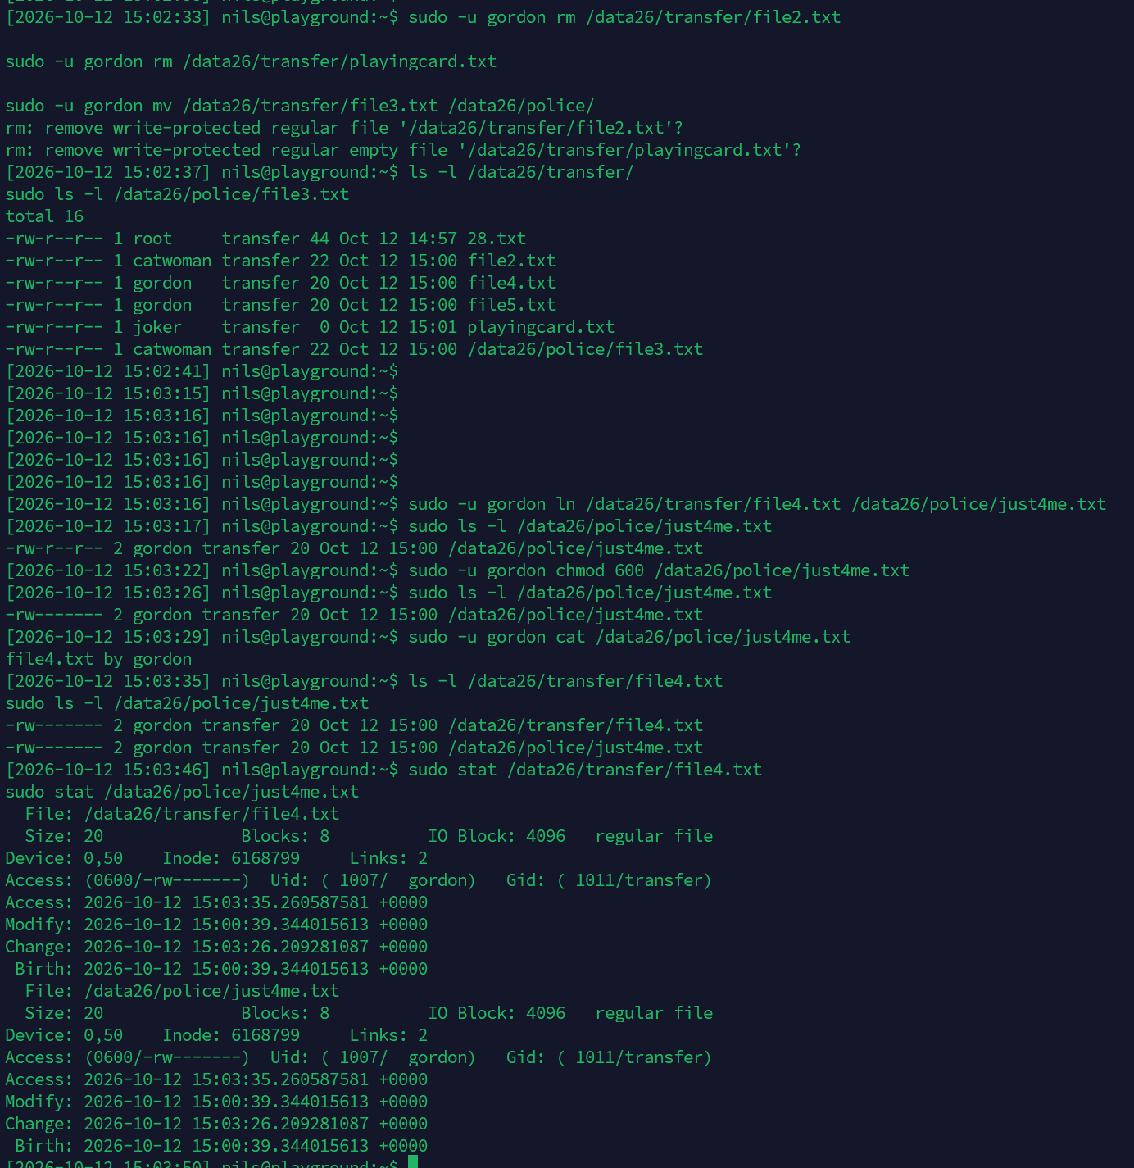
- As gordon:
  - Create a soft link soft5.txt in /data26/police that points to the same file as
/data26/transfer/file5.txt.
• Symbolic link created; it stores the target path.
  - Change the permissions of soft5.txt in such a manner that only gordon can read and write this file (nobody else has permissions for accessing this file).
• chmod 600 followed the symlink and changed the target file.
  - Compare the file permissions of soft5.txt and file5.txt and explain!
• soft5.txt shows lrwxrwxrwx; file5.txt shows -rw-------. Access depends on the target.
  - Is the inode-number of the two files the same again? How can you determine the inode-number using just the ls command (what option?)?
• Different inode numbers; display them with ls -i (or ls -li).
  - What value does their link counter have now?
• Link count = 1 for each; a symlink does not increase target link count.
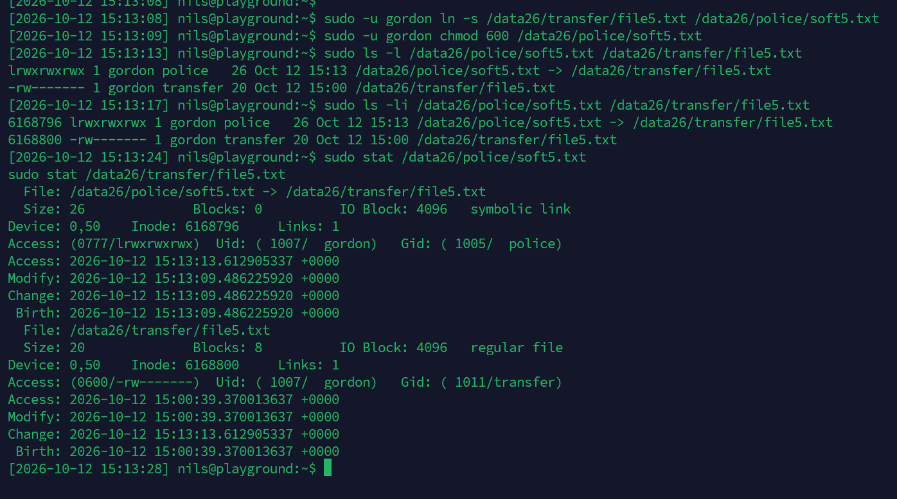
- As gordon:
  - Delete the files file4.txt and file5.txt in /data26/transfer.
• Deleted file4.txt and file5.txt as gordon.
  - What happened to the two links you created previously in /data26/police (just4me.txt and soft5.txt)? Can they still be used? Try to read each file using cat and explain!
• Hard link just4me.txt still works; soft5.txt is broken because its target was deleted.
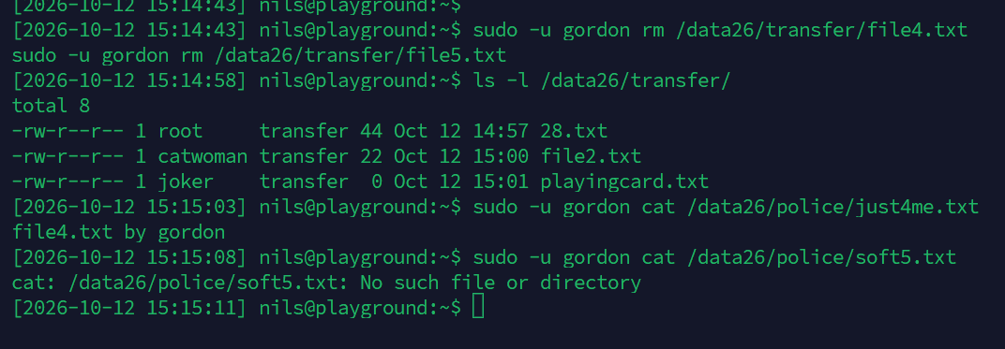
- Issue the command sudo find /data26 -ls as user root and copy the output into your lab report.
• Full post-test find output is shown in the screenshot below.
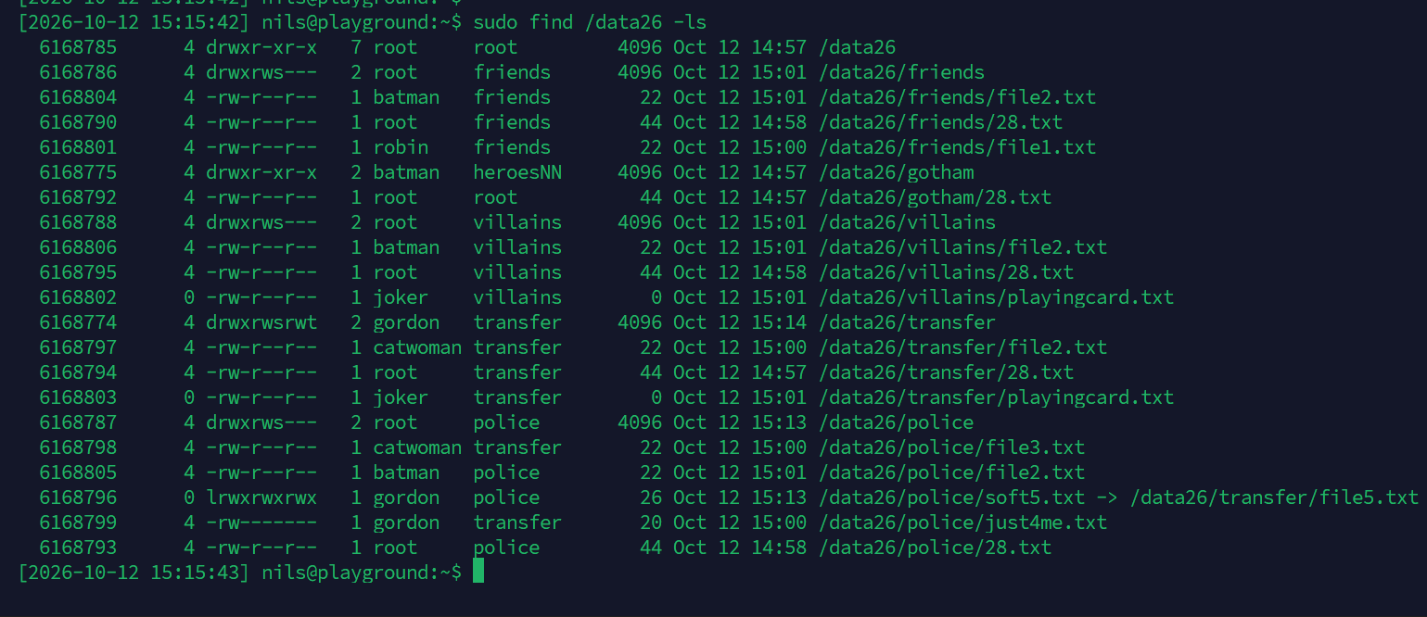
- As gordon: Delete the directory /data26/transfer with all its contents!
• Deletion as gordon failed: /data26 is 755, so gordon cannot remove its child directory.
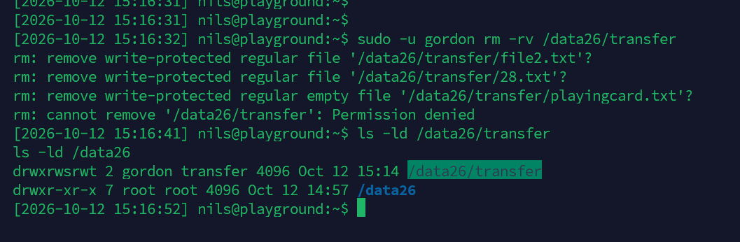
We wish you lots of success and fun with the exercise!

